Silesian University of Technology – Makrofaculty 2018  
Marek Świerkot [Group 2]

1. Project overview

Program was written as a project for one of my Makrofaculty course subjects. For the development I used C++ language with Allegro 5.0 library for displaying graphics.

Program is a game, known from old type cell phones as a Snake. Main goal in a game is to move single block, which can be assosciated with snake’s head, around 2D board and collect apples, thanks to which snake prolongs. Additionaly, quite important is that snake should not hit the wall either itself. When such happens, game is over.

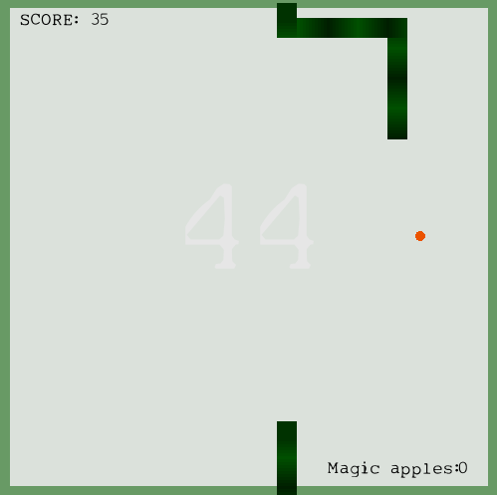

1. Snake movement

The ideas of moving snake came to me during my previous project, which actually was Snake game only written in C# langauge, where everything was displayed in system console, using arrays.

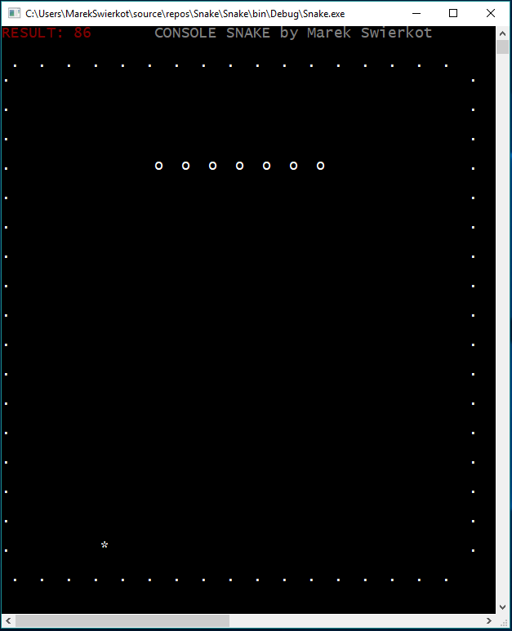

First, I thought, moving snake should be realised like that: game constatly moves snake in set direction, first saving i-th element position, moving i-th element, an seting i+1 element position for saved i-th position.  
Thing is easy, when snake moves in straight line, but when direction quicly changes in short period of time, it becomes complex, because you have to follow directions changes.

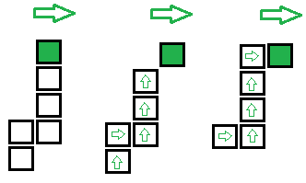

I belive this idea is simpler. Snake is still constantly moving, but its turns are realised like that. First, you check what would be the position of head, right after turn in given direction. You save the coordinates, and create new object with saved coordinates. Then, at the beggining of vector which stores all the element, you insert that object. If loop going through the vector, reaches last element, you remove last vector element.

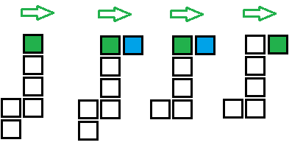

1. Food types

In game player collects two types of apples. First type, increases score by 1 and prolongs snake by 1 segment (actually its 3 new objects, so the snake is longer in shorter period of time). Second type, increases score by 2, and activates timer, counting down to 0. During that time walls are „invisible” and snake can walk through them.

1. Grid system  
     
   Every „segment” of snake is kept inside vector and each segment is represented by object. New element is added to the vector every time, when apple is eaten. In my privious project, in which everything, including displaying snake, was done using arrays, which automaticly provided grid system [size of a 2 dimensional array]. In this project I decided that there is no grid, snake can move around, not only within grid lines. Food size is intentionaly smaller than snake’s segment size, so it can be covered by segment. There is a margin, so food is also treated as eaten, even when it is covered only in 50%.

Link to the GitHub project:

<https://github.com/MarkSwierkot/SnakeAllegroCpp>

Note: Running a project may require Allegro 5.0 extension being installed in Visual Studio extensions.